**Contatos dos deputados federais de Minas Gerais**

## Aécio Neves (PSDB)

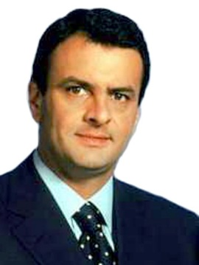

**Telefone(s):** [(61) 3215-5964](tel:+556132155964)  
**E-mail:** [dep.aecioneves@camara.leg.br](mailto:dep.aecioneves@camara.leg.br)  
**Facebook:** [facebook.com/AecioNevesOficial](http://facebook.com/AecioNevesOficial)  
**Instagram:** [instagram.com/aecionevesoficial/](http://instagram.com/aecionevesoficial/)  
**Twitter:** [twitter.com/aecioneves](https://twitter.com/aecioneves)  
**Youtube:** [youtube.com/c/AecionevesBr](https://www.youtube.com/c/AecionevesBr)

## Aelton Freitas (PL)

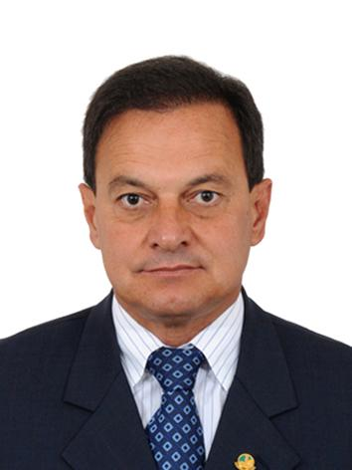

**Telefone(s):** [(61) 3215-5481](te:+556132155481)**E-mail:** [dep.aeltonfreitas@camara.leg.br](mailto:dep.aeltonfreitas@camara.leg.br)  
**Facebook:** [facebook.com/AeltonFreitasMG](https://www.facebook.com/AeltonFreitasMG)  
**Instagram:** [instagram.com/dep.aelton/](https://www.instagram.com/dep.aelton/)   
**Twitter:** [twitter.com/aeltonfreitasmg](https://twitter.com/aeltonfreitasmg) (Inativo)

## Alê Silva (PSL)

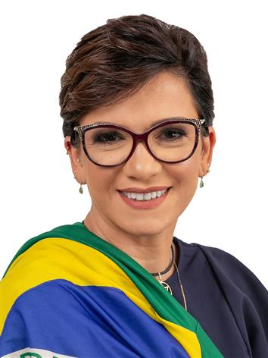

**Telefone:** [(61) 3215-5462](tel:+556132155462)  
**Whatsapp:** [+55 31 98936-4204](https://api.whatsapp.com/send?phone=5531989364204&text=Ol%C3%A1%20esse%20%C3%A9%20o%20WhatsApp%20da%20Deputada%20Federal%20Al%C3%AA%20Silva,%20muito%20obrigada%20por%20entrar%20em%20contato,%20responderei%20o%20mais%20r%C3%A1pido%20poss%C3%ADvel.)  
**E-mail:** [dep.alesilva@camara.leg.br](mailto:dep.alesilva@camara.leg.br)  
**Facebook:** [facebook.com/AleSilvaOficial](https://www.facebook.com/AleSilvaOficial)  
**Instagram:** [instagram.com/alesilva.oficial/](https://www.instagram.com/alesilva.oficial/)  
**Twitter:** [twitter.com/alesilva_38](https://twitter.com/alesilva_38)  
**Youtube:** [youtube.com/c/Al%C3%AASilvaOficial](https://www.youtube.com/c/Al%C3%AASilvaOficial)

## André Janones (Novo)

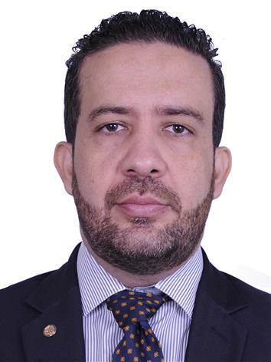

**Telefone:** [(61) 3215-5580](tel:+556132155580)  
**E-mail:** [dep.andrejanones@camara.leg.br](mailto:dep.andrejanones@camara.leg.br)  
**Facebook:** [facebook.com/AndreJanones](https://www.facebook.com/AndreJanones)   
**Instagram:** [instagram.com/andrejanones/](https://www.instagram.com/andrejanones/)  
**Twitter:** [twitter.com/AndreJanonesAdv](https://twitter.com/AndreJanonesAdv)  
**Youtube:** [youtube.com/user/AndreJanonesAdv](https://www.youtube.com/user/AndreJanonesAdv)

## Áurea Carolina (PSOL)

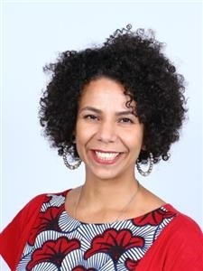

**Telefone:** [(61) 3215-5619](tel:+556132155619)  
**Whatsapp:** [+55 31 99703-5018](https://api.whatsapp.com/send?phone=5531997035018&text=%C3%81urea,%20estamos%20juntas!)  
**E-mail:** [dep.aureacarolina@camara.leg.br](mailto:dep.aureacarolina@camara.leg.br)  
**Facebook:** [facebook.com/aureacarolina/](https://www.facebook.com/aureacarolina/)  
**Instagram:** [instagram.com/aureacarolina/](https://www.instagram.com/aureacarolina/)  
**Twitter:** [twitter.com/aureacarolinax](https://twitter.com/aureacarolinax)  
**Tiktok:** [tiktok.com/@aureacarolinax](https://www.tiktok.com/@aureacarolinax)  
**Youtube:** [youtube.com/c/%C3%81ureaCarolinax](https://www.youtube.com/c/%C3%81ureaCarolinax)

## Bilac Pinto (DEM)

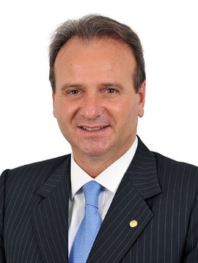

**Telefone:** [(61) 3215-5806](tel:+556132155806) / [(31) 3299-5558](tel:+553132995558)  
**Whatsapp:** [+55 31 9916-3741](https://api.whatsapp.com/send?phone=553199163741)  
**E-mail BSB:** [dep.bilacpinto@camara.leg.br](mailto:dep.bilacpinto@camara.leg.br)  
**E-mail BH:** [deputadobilacpinto@globo.com](mailto:deputadobilacpinto@globo.com)  
**Facebook:** [facebook.com/depbilacpinto/](https://www.facebook.com/depbilacpinto/)  
**Twitter:** [twitter.com/depbilacpinto](https://twitter.com/depbilacpinto?fbclid=IwAR0i5VjoyjmdklzZL3QGe-N4nRUcN52CnQP6-ptZoUU6v3UDBxylTd5uF4o)  
**Instagram:** [instagram.com/bilacpinto](https://www.instagram.com/bilacpinto)  
**Youtube:** [youtube.com/channel/UCnqX6_qvfmq6YYP2UE1aajA](https://www.youtube.com/channel/UCnqX6_qvfmq6YYP2UE1aajA)

## Charles Evangelista (PSL)

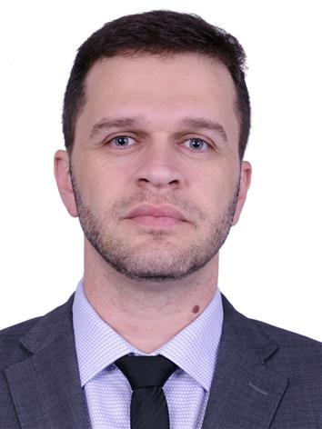

**Telefone:** [(61) 3215-5517](tel:+556132155517) / [(32) 3321-1276](tel:+553233211276) (Juiz de Fora)  
**E-mail:** [dep.charllesevangelista@camara.leg.br](mailto:dep.charllesevangelista@camara.leg.br)  
**E-mail 2:** [assessoriacharlles@gmail.com](mailto:assessoriacharlles@gmail.com)  
**Facebook:** [facebook.com/charlles.evangelista](https://www.facebook.com/charlles.evangelista)  
**Instagram**: [instagram.com/charlles.evangelista/](https://www.instagram.com/charlles.evangelista/)  
**Twitter:** [twitter.com/charllesevg](https://twitter.com/charllesevg)**Youtube:** [youtube.com/channel/UCV7BXa77tGklAsuSx9DuZOQ](https://www.youtube.com/channel/UCV7BXa77tGklAsuSx9DuZOQ)

## Delegado Marcelo Freitas (PSL)

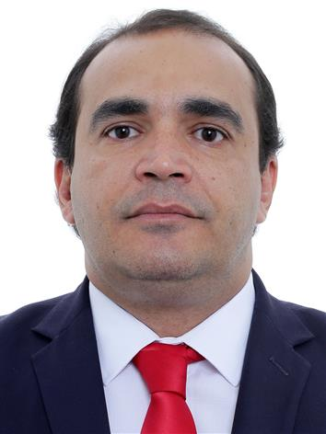

**Telefone:** [(61) 3215-5548](tel:+556132155548) / [(31) 3656-0610](tel:+553136560610)  
**Whatsapp:** [+55 38 99250-1777](https://api.whatsapp.com/send?phone=5538992501777)  
**E-mail:** [dep.delegadomarcelofreitas@camara.leg.br](mailto:dep.delegadomarcelofreitas@camara.leg.br)  
**E-mail 2:** [delegadomarcelofreitas@gmail.com](mailto:delegadomarcelofreitas@gmail.com)  
**Facebook:** [facebook.com/delegadomarcelofreitas](https://www.facebook.com/delegadomarcelofreitas)  
**Instagram:** [instagram.com/delegadomarcelofreitas/](https://www.instagram.com/delegadomarcelofreitas/)  
**Twitter:** [twitter.com/DelegadoFreitas](https://twitter.com/DelegadoFreitas)  
**Youtube:** [youtube.com/channel/UC-YDFg5FTo1FKRkav_mD6oQ](https://www.youtube.com/channel/UC-YDFg5FTo1FKRkav_mD6oQ)

## Diego Andrade (PSD)

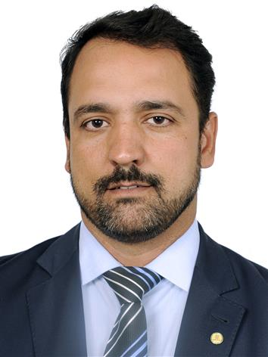

**Telefone:** [(61) 3215-5307](tel:+556132155307)  
**E-mail:** [dep.diegoandrade@camara.leg.br](mailto:dep.diegoandrade@camara.leg.br)  
**Facebook:** [facebook.com/diegoandrademg](https://www.facebook.com/diegoandrademg)  
**Instagram:** [instagram.com/diegoandrademg](https://www.instagram.com/diegoandrademg)  
**Twitter:** Não tem  
**Youtube:** Não tem

## Dimas Fabiano (PP)

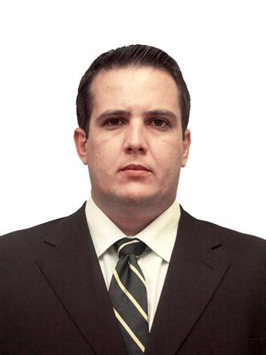

**Telefone:** [(61) 3215-5736](tel:+556132155736)  
**E-mail:** [dep.dimasfabiano@camara.leg.br](mailto:dep.dimasfabiano@camara.leg.br)  
**Facebook:** [facebook.com/depdimasfabiano.toledo](https://www.facebook.com/depdimasfabiano.toledo)  
**Instagram:** [instagram.com/depdimas/](https://www.instagram.com/depdimas/)  
**Twitter:** [twitter.com/depdimasfabiano](https://twitter.com/depdimasfabiano) (inátivo)  
**Youtube:** Não tem

## Domingos Sávio (PSDB)

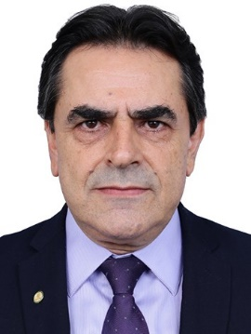

**Telefone:** [(61) 3215-5345](tel:+556132155345)  
**E-mail:** [dep.domingossavio@camara.leg.br](mailto:dep.domingossavio@camara.leg.br)  
**E-mail 2:** [contato@deputadodomingossavio.com.br](mailto:contato@deputadodomingossavio.com.br)  
**Facebook:** [facebook.com/domingossaviomg](https://www.facebook.com/domingossaviomg)  
**Instagram:** [instagram.com/domingossaviomg/](https://www.instagram.com/domingossaviomg/)  
**Twitter:** [twitter.com/domingossaviomg](https://twitter.com/domingossaviomg)  
**Youtube:** [youtube.com/user/depdomingossavio](https://www.youtube.com/user/depdomingossavio)

## Dr. Frederico (PATRIOTA)

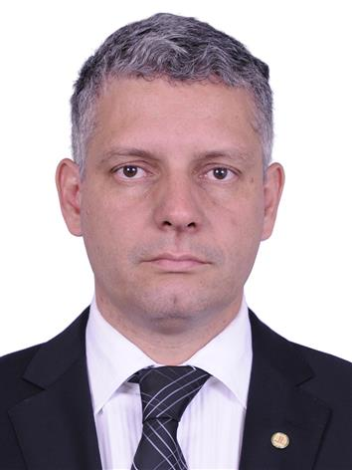

**Telefone:** [(61) 3215-5568](tel:+556132155568) / [(32) 3372 5684](tel:+553233725684) (São João del Rei)  
**E-mail:** [dep.dr.frederico@camara.leg.br](mailto:dep.dr.frederico@camara.leg.br)  
**Facebook:** [facebook.com/DrFredericoMG](https://www.facebook.com/DrFredericoMG)  
**Instagram:** [instagram.com/DrFredericoMG/](https://www.instagram.com/DrFredericoMG/)  
**Twitter:** [twitter.com/DrFredericoMG](https://twitter.com/DrFredericoMG)  
**Youtube:** [youtube.com/channel/UCECMUExjKs5WSw56VzOV3Dg/](https://www.youtube.com/channel/UCECMUExjKs5WSw56VzOV3Dg/)

## Eduardo Barbosa (PSDB)

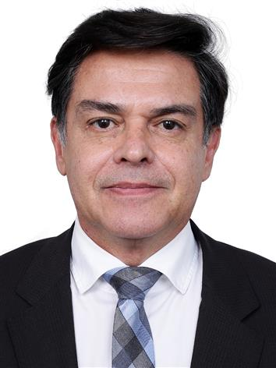

**Telefone(s):** [(61) 3215-5540](tel:+55613215-5540)  
**E-mail:** [dep.eduardobarbosa@camara.leg.br](mailto:dep.eduardobarbosa@camara.leg.br)  
**E-mail 2:** [eduardobarbosagabinetemg@gmail.com](mailto:eduardobarbosagabinetemg@gmail.com)  
**Facebook:** [facebook.com/deputadofederaleduardobarbosa/](https://www.facebook.com/deputadofederaleduardobarbosa/)**Instagram:** [instagram.com/eduardobarbosamg/](https://www.instagram.com/eduardobarbosamg/)  
**Twitter:** [twitter.com/eduardobarbosa_](https://twitter.com/eduardobarbosa_)  
**Youtube:** [youtube.com/channel/UCeg3MIih6hmEvNniGh9kw4g/featured](https://www.youtube.com/channel/UCeg3MIih6hmEvNniGh9kw4g/featured)

## Emidinho Madeira (PSB)

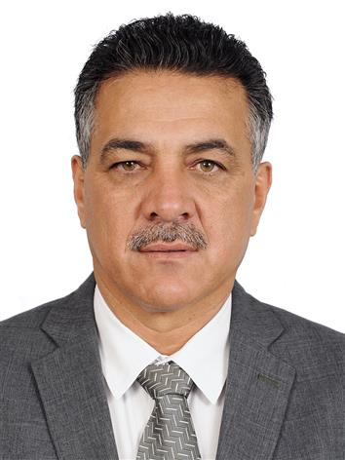

**Telefone:** [(61) 3215-5837](tel:+55613215-5837)  
**Whatsapp:** [+55 31 99815-6363](https://api.whatsapp.com/send?phone=5531998156363)  
**E-mail:** [dep.emidinhomadeira@camara.leg.br](mailto:dep.emidinhomadeira@camara.leg.br)  
**Facebook:** [facebook.com/emidinhomadeira/](https://www.facebook.com/emidinhomadeira/)  
**Instagram:** [instagram.com/emidinhomadeira/](https://www.instagram.com/emidinhomadeira/)  
**Youtube:** [youtube.com/channel/UCN3Gftu4Sd6AaDrz4uSvfXA](https://www.youtube.com/channel/UCN3Gftu4Sd6AaDrz4uSvfXA)

## Eros Biondini (PROS-MG)

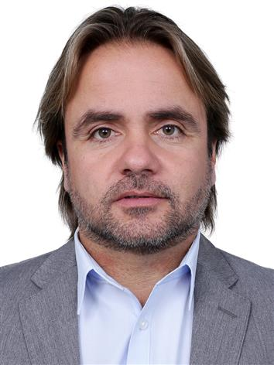

**Telefone:**  (61) 3215-5321  
**Whatsapp:** [+55 (31) 98358-2232](https://api.whatsapp.com/send?phone=553183582232)  
**E-mail:** [dep.erosbiondini@camara.leg.br](mailto:dep.erosbiondini@camara.leg.br)  
**Facebook:** [facebook.com/erosbiondini](https://www.facebook.com/erosbiondini)  
**Instagram:** [instagram.com/erosbiondini](https://www.instagram.com/erosbiondini)  
**Twitter:** [twitter.com/erosbiondini](https://twitter.com/erosbiondini)  
**Youtube:** [youtube.com/c/ErosBiondiniOficial/](https://www.youtube.com/c/ErosBiondiniOficial/)

## Euclydes Pettersen (PSC)

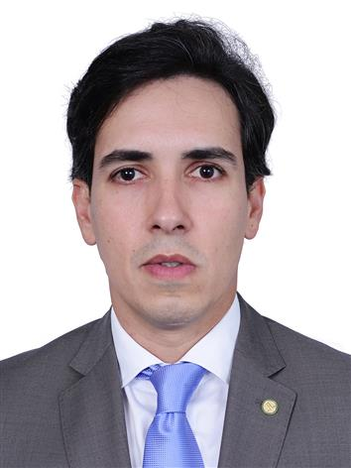

**Telefone:** (61) 3215-5456  
**E-mail:** [dep.euclydespettersen@camara.leg.br](mailto:dep.euclydespettersen@camara.leg.br)  
**E-mail 2:** [euclydes2018@gmail.com](mailto:euclydes2018@gmail.com)  
**Facebook:** [facebook.com/EuclydesPettersenOficial](https://www.facebook.com/EuclydesPettersenOficial)  
**Instagram:** [instagram.com/euclydespettersenoficial/](https://www.instagram.com/euclydespettersenoficial/)  
**Twitter:** [twitter.com/EuclydesPetter](https://twitter.com/EuclydesPetter)

## Fábio Ramalho (MDB)

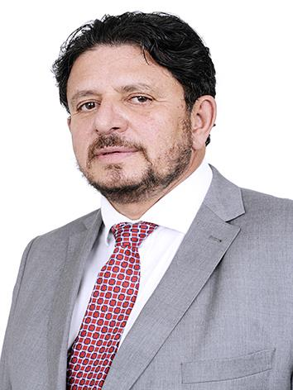

**Telefone(s):** [(61) 3215-5826](tel:+55613215-5826)  
**E-mail:** [dep.fabioramalho@camara.leg.br](mailto:dep.fabioramalho@camara.leg.br)  
**E-mail 2:** [fabinhoramalhomg@gmail.com](mailto:fabinhoramalhomg@gmail.com)  
**Facebook:** [facebook.com/deputadofabioramalho4311/](https://www.facebook.com/deputadofabioramalho4311/)  
**Instagram:** [instagram.com/deputadofabioramalho](https://www.instagram.com/deputadofabioramalho)  
**Twitter:** [twitter.com/deputadofabiomg](https://twitter.com/deputadofabiomg)

## Franco Cartafina (PP)

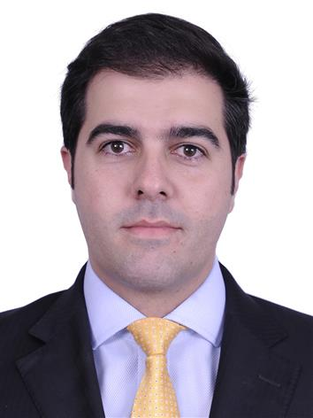

**Telefone:** [(61) 3215-5283](tel:+55(61)%203215-5283)  
**Whatsapp:** [+55 34 99271-0031](https://api.whatsapp.com/send?phone=5534992710031)  
**E-mail:** [dep.francocartafina@camara.leg.br](mailto:dep.francocartafina@camara.leg.br)  
**E-mail 2:** [contato@francocartafina.com.br](mailto:contato@francocartafina.com.br)  
**Facebook:** [facebook.com/franco.cartafina.75/](https://www.facebook.com/franco.cartafina.75/)  
**Instagram:** [instagram.com/francocartafina/](https://www.instagram.com/francocartafina/)  
**Youtube:** [youtube.com/c/CanalFrancoCartafina/](https://www.youtube.com/c/CanalFrancoCartafina/)

## Fred Costa (PATRIOTA)

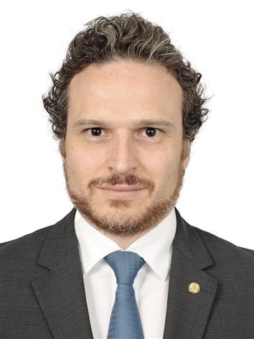

**Telefone(s):** [(61) 3215-5633](tel:+55613215-5633)  
**E-mail:** [dep.fredcosta@camara.leg.br](mailto:dep.fredcosta@camara.leg.br)  
**Facebook:** [facebook.com/FredCostaDeputado](https://www.facebook.com/FredCostaDeputado)  
**Twitter:** [twitter.com/FredCostaDep](https://twitter.com/FredCostaDep)  
**Instagram:** [instagram.com/FredCostaDEP/](https://www.instagram.com/FredCostaDEP/)

## Gilberto Abramo (REPUBLICANOS)

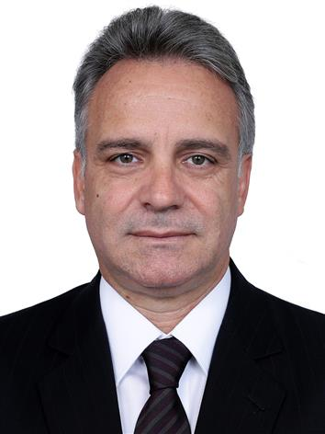

**Telefone(s):** [(61) 3215-5601](tel:(61)%203215-5601)  
**E-mail:** [dep.gilbertoabramo@camara.leg.br](mailto:dep.gilbertoabramo@camara.leg.br)  
**Facebook:** [facebook.com/gilbertoabramo1010](https://www.facebook.com/gilbertoabramo1010)  
**Instagram:** [instagram.com/gilbertoabramo_/](https://www.instagram.com/gilbertoabramo_/)  
**Twitter:** [twitter.com/gilbertoabramo](https://twitter.com/gilbertoabramo)  
**Youtube:** [youtube.com/channel/UCrGCpAc-KUfox0ZKypnSp7w](https://www.youtube.com/channel/UCrGCpAc-KUfox0ZKypnSp7w)

## Greyce Elias (AVANTE)

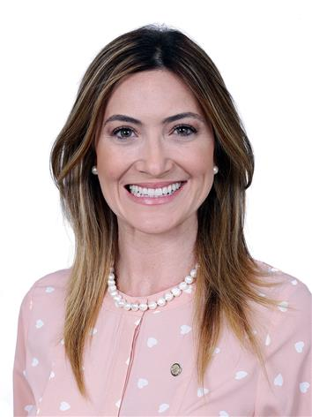

**Telefone:** [(61) 3215-5340](tel:(61)%203215-5340)  
**E-mail:** [dep.greyceelias@camara.leg.br](mailto:dep.greyceelias@camara.leg.br)  
**E-mail 2:** [deputadagreyceelias@gmail.com](mailto:deputadagreyceelias@gmail.com)  
**Facebook:** [facebook.com/greyce.elias](https://www.facebook.com/greyce.elias)  
**Instagram:** [instagram.com/greyceelias/](https://www.instagram.com/greyceelias/)  
**Twitter:** [twitter.com/greyceelias](https://twitter.com/greyceelias)

## Hercílio Coelho Diniz (MDB)

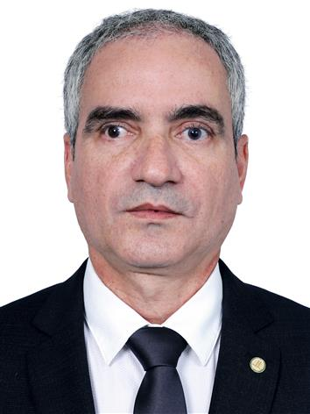

**Telefone:** [(61) 3215-5510](tel:(61)%203215-5510)  
**E-mail:** [dep.herciliocoelhodiniz@camara.leg.br](mailto:dep.herciliocoelhodiniz@camara.leg.br)  
**Facebook:** [facebook.com/herciliocoelhodinizoficial/](https://www.facebook.com/herciliocoelhodinizoficial/)  
**Instagram:** [instagram.com/herciliocoelhodinizoficial/](https://www.instagram.com/herciliocoelhodinizoficial/)  
**Twitter:** [twitter.com/herciliodiniz](https://twitter.com/herciliodiniz)  
**Youtube:** [youtube.com/c/Herc%C3%ADlioCoelhoDinizOficial/](https://www.youtube.com/c/Herc%C3%ADlioCoelhoDinizOficial/)

## Igor Timo (PODE)

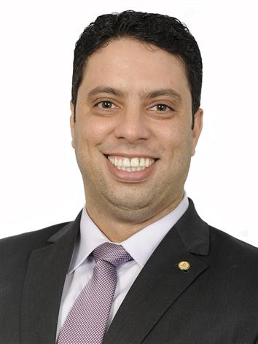

**Telefone:** [(61) 3215-5726](tel:+556132155726)  
**Whatsapp**: [+55 38 99881-1999](https://api.whatsapp.com/send?phone=5538998811999)  
**E-mail:** [dep.igortimo@camara.leg.br](mailto:dep.igortimo@camara.leg.br)  
**E-mail 2:** [igortimo2018@gmail.com](mailto:igortimo2018@gmail.com)  
**Facebook:** [facebook.com/oficialigortimo](https://www.facebook.com/oficialigortimo)  
**Twitter:** [twitter.com/oficialigortimo](https://twitter.com/oficialigortimo)  
**Instagram:** [instagram.com/oficialigortimo](https://www.instagram.com/oficialigortimo)

## Júlio Delgado (PSB)

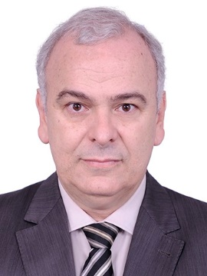

**Telefone:**  [(61) 3215-5323](tel:+55(61)%203215-5323) / [(32) 3215-3058](tel:+553262153058)  
**E-mail:** [dep.juliodelgado@camara.leg.br](mailto:dep.juliodelgado@camara.leg.br)  
**Facebook:** [facebook.com/depjuliodelgado](https://www.facebook.com/depjuliodelgado)  
**Twitter:** [twitter.com/depjuliodelgado](https://twitter.com/depjuliodelgado)  
**Instagram:** [instagram.com/depjuliodelgado/](https://www.instagram.com/depjuliodelgado/)  
**Youtube:** [youtube.com/user/depjuliodelgado](https://www.youtube.com/user/depjuliodelgado)

## Junio Amaral (PSL)

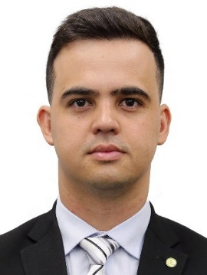

**Telefone(s):** [(61) 3215-5302](tel:+55(61)%203215-5302)  
**Whatsapp:** [(31) 99939-5199](https://api.whatsapp.com/send?phone=553199395199)  
**E-mail:** [dep.junioamaral@camara.leg.br](mailto:dep.junioamaral@camara.leg.br)  
**Facebook:** [facebook.com/cabojunioamaral](https://www.facebook.com/cabojunioamaral)  
**Twitter:** [twitter.com/cabojunioamaral](https://twitter.com/cabojunioamaral)  
**Instagram:** [instagram.com/cabojunioamaral](https://www.instagram.com/cabojunioamaral)

## Lafayette de Andrada (REPUBLICANOS)

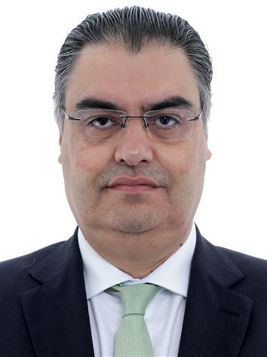

**Telefone(s):** [(61) 3215-5208](tel:+55(61)%203215-5208)  
**Whatsapp:** [+55 31 99975-3633](https://api.whatsapp.com/send?phone=5531999753633)  
**E-mail:** [dep.lafayettedeandrada@camara.leg.br](mailto:dep.lafayettedeandrada@camara.leg.br)  
**Facebook:** [facebook.com/lafayettedeandrada/](https://www.facebook.com/lafayettedeandrada/)  
**Instagram:** [instagram.com/lafayetteandrada/](https://www.instagram.com/lafayetteandrada/)  
**Twitter:** [twitter.com/lafayetteandrad](https://twitter.com/lafayetteandrad)  
**Youtube:** [youtube.com/channel/UC5f8X2JAnafqV7bPLmDeZGw](https://www.youtube.com/channel/UC5f8X2JAnafqV7bPLmDeZGw)

## Léo Motta (PSL)

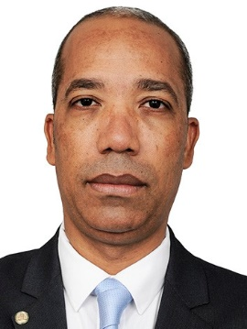

**Telefone:** [(61) 3215-5724](tel:+556132155724)  
**Whatsapp:** [+55 31 98808-1700](https://api.whatsapp.com/send?phone=5531988081700)  
**E-mail:** [dep.leomotta@camara.leg.br](mailto:dep.leomotta@camara.leg.br)  
**E-mail 2:** [leomottafederal@gmail.com](mailto:leomottafederal@gmail.com)  
**Facebook:** [facebook.com/leomottafederal/](https://www.facebook.com/leomottafederal/)  
**Instagram:** [instagram.com/leomottaoficial/](https://www.instagram.com/leomottaoficial/)  
**Twitter:** [twitter.com/leomotta_ofc](https://twitter.com/leomotta_ofc)  
**Youtube:** [youtube.com/channel/UC_hevXOizQma0kBn5KlCm2w](https://www.youtube.com/channel/UC_hevXOizQma0kBn5KlCm2w)